



IoT based

Smart Campus Waste Management

**Project Created by:** Harikrishnan J, Harish P M, Gopinath D

**Project Reviewed by:** Neelakantan N S **Project Created Date:** 30/May/2024 **Project Code:** IoT 001

**College Code:** 4126

**Team Name:** IOT 1787

# Executive Summary

The IoT-Based Smart Waste Management System enhances waste collection efficiency by using sensors in bins to monitor fill levels and provide real-time data to the Blynk web platform. This integration allows for remote management, enabling efficient scheduling and routing of waste collection based on actual bin statuses, thus reducing unnecessary trips, saving costs, and benefiting the environment. The project follows a structured process of requirement analysis, system design, implementation, testing, and deployment, successfully addressing challenges like sensor integration and data reliability through collaboration and iterative development. Initial results demonstrate effective remote monitoring and management, marking a significant advancement in waste management technology with improved efficiency, cost-effectiveness, and environmental sustainability. Additionally, the system offers scalability for use in various urban and rural settings and can be integrated with other smart city solutions. This adaptability ensures that municipalities can better manage resources, respond quickly to waste management needs, and provide cleaner, healthier environments for their communities.

# Table of Contents:

Contents

Executive Summary 2

Table of Contents 3

Project Objective 4

Scope 5

Methodology 5

Artifacts used 6

Technical coverage 8

Results 12

Challenges and Resolutions 13

Conclusion 14

References 15

# Project Objective:

The primary objective of this project is to elevate the functionality of existing waste management systems by transitioning them into an Internet of Things (IoT)-based solution. This evolution will be achieved through seamless integration with the Blynk web console, facilitating remote monitoring and control of waste bins. By incorporating IoT principles, the project endeavors to empower stakeholders with the ability to access real-time updates and perform data analysis remotely, thereby enhancing the efficiency and efficacy of waste collection operations. This transformation marks a pivotal step towards modernizing traditional waste management mechanisms, offering a dynamic and flexible approach to waste regulation. Through the utilization of IoT technologies, the project aspires to bridge the gap between conventional waste management systems and contemporary digital solutions, ushering in a new era of smart and responsive urban infrastructure. The integration with the Blynk web console not only enables remote accessibility but also opens avenues for future enhancements and innovations in waste management methodologies. Overall, the project aims to harness the potential of IoT to revolutionize waste management practices, fostering cleaner, more efficient, and environmentally sustainable urban communities.

# Scope:

The project's scope entails a comprehensive transformation of the Waste Management System to seamlessly integrate with the Blynk IoT platform, facilitating remote access and control through web or mobile interfaces. This adaptation necessitates an overhaul of both hardware and software components to ensure compatibility and functionality with the Blynk ecosystem. Furthermore, configuring the Blynk dashboard to accommodate the specific requirements of waste management adds another layer of complexity to the project scope. Additionally, robust communication protocols need to be implemented to facilitate seamless data exchange between the Waste Management System and the Blynk platform, ensuring reliable and secure remote access and control capabilities. The scope also encompasses rigorous testing and validation procedures to verify the effectiveness and reliability of the integrated system. Furthermore, documentation and training materials may be developed to facilitate the deployment and utilization of the IoT-enabled Waste Management System. Overall, the project's scope extends beyond mere integration to encompass a holistic transformation aimed at enhancing functionality, accessibility, and efficiency in waste management through IoT technology.

# Methodology

The project follows a systematic approach:

**Requirement Analysis:** Identifying the requirements for IoT integration and remote monitoring.

**System Design:** Designing the architecture for integrating the smart waste management system with the Blynk web console.

**Implementation:** Updating the hardware and software components, configuring the Blynk dashboard, and programming communication protocols.

**Testing and Validation:** Conducting testing to ensure the reliability and functionality of the IoT-based smart waste management system.

**Deployment:** Deploying the system and conducting real-world testing to verify performance.

# Artifacts used

The following artifacts were utilized throughout the project:

• **Waste Level Data**: Real-time data collected from sensors in waste bins, indicating fill levels and other relevant metrics.

• **Blynk Library**: Arduino library for interfacing with the Blynk platform, facilitating the sending and receiving of data between waste bins and the web console.

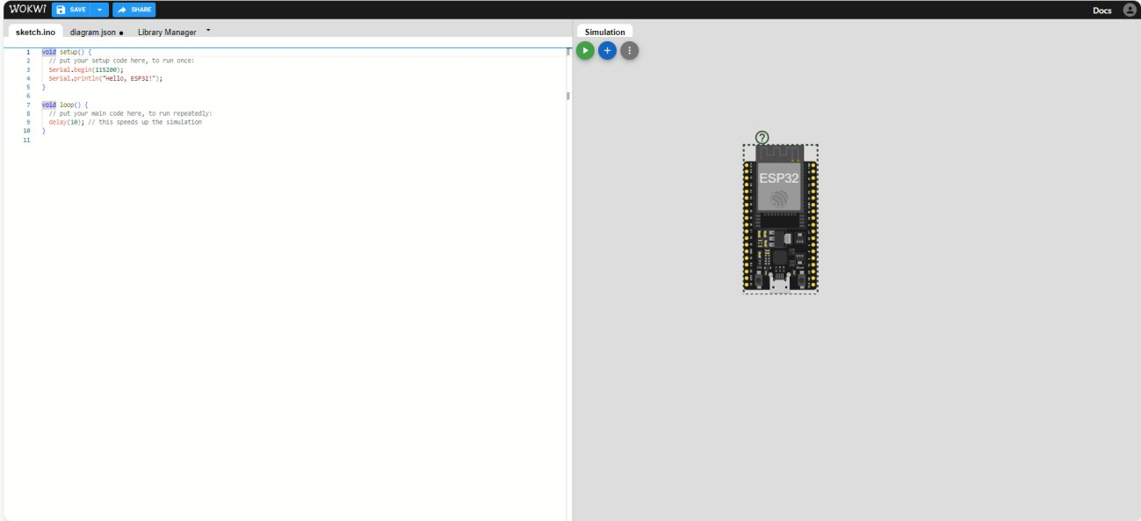• **Wokwi Online Simulator Tool**: Used for testing and debugging Arduino code to ensure proper functionality of the IoT-based waste management system before deployment.

* **Blynk IoT Platform:** Web console and mobile app for IoT device control and data visualization.

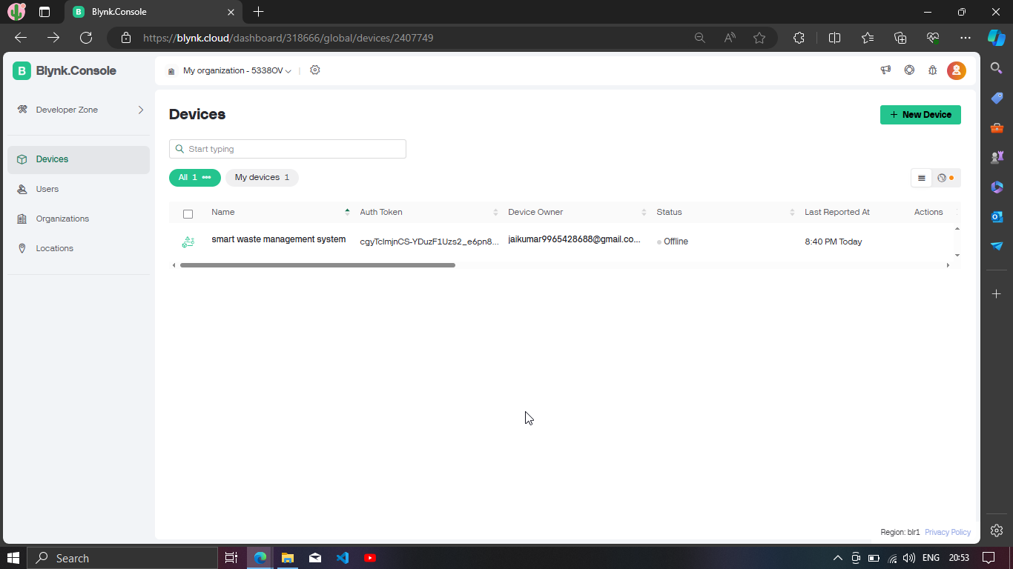

* **ESP32 Wi-Fi Module:** Hardware platform for enabling Wi-Fi connectivity and IoT capabilities.

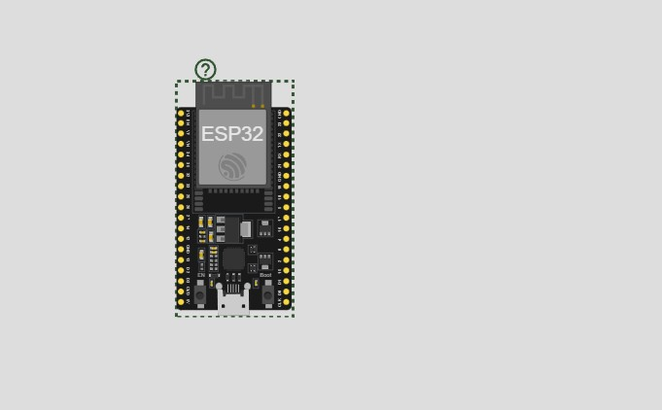

# Technical coverage:

The IoT based Traffic Control System provides the following technical functionalities:

**Waste Level Monitoring**: Real-time monitoring of waste levels in bins using sensors to determine fill status and prevent overflow.

**Optimized Collection Scheduling**: Dynamic adjustment of waste collection schedules based on current bin fill levels to enhance efficiency.

**Overflow Alerts**: Detection of bin overflow and generation of alerts to ensure timely waste collection and maintain cleanliness.

**Remote Monitoring**: Real-time monitoring of bin statuses like temperature and water content and system performance via the Blynk dashboard.

**Remote Control**: Ability to remotely adjust waste collection parameters and configurations using the Blynk web or mobile interface.

**Data Logging**: Logging of waste level data and system performance metrics for analysis and optimization.

**Maintenance Alerts**: Notification of sensor malfunctions or maintenance needs to ensure the system operates smoothly.

## I.Function Description:

The Smart Waste Management Logic functions as follows:

1. Waste Level Detection:

High Level: When the ultrasonic sensor detects that the waste level is high (bin is almost full), the system sends an alert to the Blynk web console indicating "Bin Full." This triggers an immediate collection request.

Medium Level: When the waste level is medium, the system sends an alert to the Blynk web console indicating "Bin Half Full," suggesting that the bin will need attention soon.

Low Level: When the waste level is low, the system sends an alert to the Blynk web console indicating "Bin Empty," showing that the bin has ample capacity.

2. Temperature Monitoring:

High Temperature: If the temperature sensor detects a high temperature inside the bin, the system sends an alert to the Blynk web console indicating "High Temperature." This may suggest the presence of potentially hazardous waste and requires immediate attention.

Normal Temperature: If the temperature is within the normal range, the system updates the Blynk web console with "Temperature Normal," ensuring that the bin environment is safe.

3. Moisture Detection:

High Moisture: If the moisture sensor detects a high water content, the system sends an alert to the Blynk web console indicating "High Moisture." This may indicate liquid waste or potential leakage and necessitates prompt action.

Low Moisture: If the moisture level is low, the system updates the Blynk web console with "Moisture Normal," indicating that the bin contents are relatively dry.

4. Transition Phases:

The system transitions between different states (e.g., from medium to high waste level) and updates the Blynk web console with the current status, ensuring continuous monitoring and timely updates.

5. Remote Monitoring and Control:

Using the Blynk web console, users can remotely monitor the status of each bin, including waste level, temperature, and moisture content. They can also adjust parameters and settings as needed to optimize waste management operations.

6. Alerts and Notifications:

The system logs data and sends real-time alerts to the Blynk web console for any significant changes or potential issues, ensuring timely responses and efficient waste management.

This integration of sensors and remote monitoring ensures that the waste management system operates efficiently, preventing overflow and maintaining optimal conditions within the bins.

## II.Circuit Diagram:

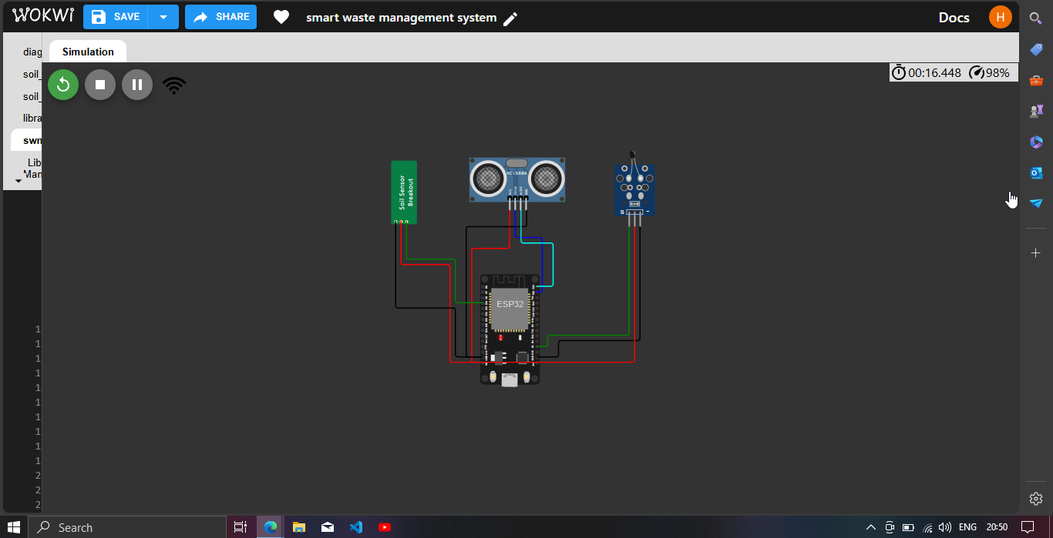

**III.Blynk Web Console:**

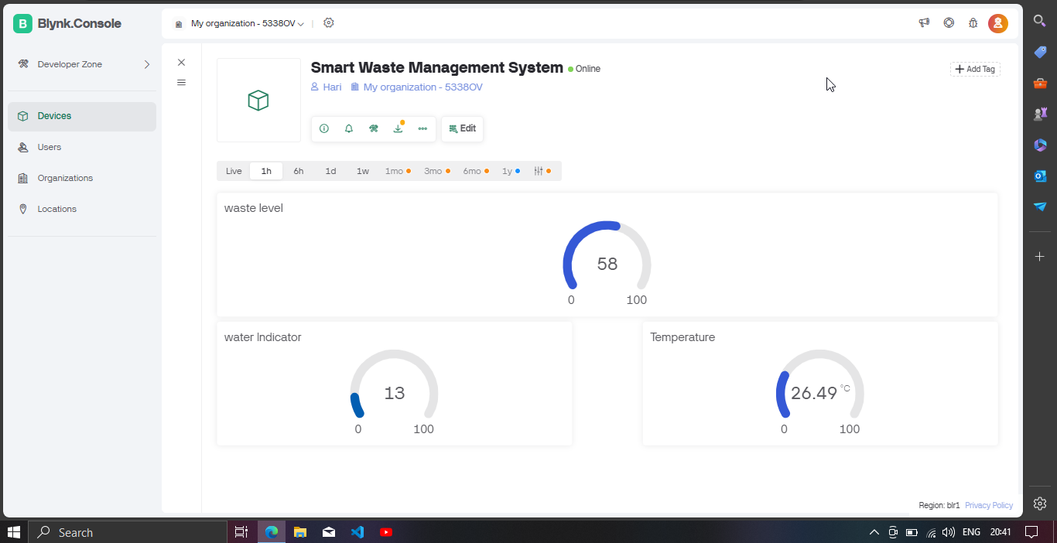

# Results

The initial results of the project demonstrate promising outcomes for the IoT-Based Smart Waste Management System, showcasing its capabilities in remote monitoring and control:

1. **Integration with Blynk Platform**: The system successfully integrates with the Blynk platform, enabling users to monitor waste levels, temperature, and moisture content remotely.
2. **Remote Accessibility**: Users can conveniently access the Blynk mobile or web application from anywhere with an internet connection, allowing for real-time monitoring and management of waste bins.
3. **Real-time Data**: The system provides real-time data on waste levels, temperature, and moisture content, empowering users to make informed decisions regarding waste management strategies and resource allocation.
4. **Customizable Interface**: The Blynk platform offers a customizable user interface, allowing users to tailor the display and controls according to their specific needs and preferences.
5. **Alert Notifications**: Users receive instant notifications on their mobile devices in case of any system abnormalities or emergencies, ensuring prompt response and resolution to potential issues such as bin overflow or high temperatures.
6. **Data Logging**: The system logs historical data on waste levels, temperature, and moisture content, enabling users to track trends over time and optimize waste management operations based on data-driven insights.
7. **User Authentication**: The Blynk platform offers robust user authentication mechanisms, ensuring secure access to the system and preventing unauthorized control or tampering.
8. **Scalability**: The system is scalable and can be easily expanded to monitor and manage waste bins across multiple locations or larger geographic areas, accommodating the needs of growing urban environments.
9. **Reliability**: Through rigorous testing and validation, the system demonstrates reliability in delivering accurate real-time data and responding effectively to user commands, ensuring continuous operation and minimal downtime.
10. **User-Friendly Interface**: The Blynk mobile and web applications feature intuitive interfaces, making it easy for users to navigate and operate the system, even with limited technical expertise.
11. **Compatibility**: The system is compatible with a wide range of devices, including smartphones, tablets, and desktop computers, ensuring accessibility for users across various platforms and devices.
12. **Remote Diagnostics**: The Blynk platform allows for remote diagnostics and troubleshooting, enabling rapid resolution of any technical issues or malfunctions, thereby minimizing disruptions to waste management operations.
13. **Cost-effectiveness**: Implementing the system with the Blynk platform offers a cost-effective solution compared to traditional waste management systems, with potential savings in operational costs and resource utilization.
14. **Community Support**: The Blynk platform boasts a vibrant community of developers and users, providing access to a wealth of resources, tutorials, and support forums for ongoing system maintenance and optimization.
15. **Future Expansion**: The modular architecture of the system allows for future expansion and integration with additional features or third-party services to further enhance its capabilities and address evolving waste management needs.
16. **Continuous Improvement**: The project team remains committed to continuous improvement, seeking feedback from stakeholders and implementing updates and enhancements to the system as needed, ensuring its continued relevance and effectiveness in addressing urban waste management challenges.
17. **Stakeholder Engagement**: Engaging with stakeholders, including local authorities, waste management agencies, and community members, fosters collaboration and ensures alignment with broader waste management goals and objectives.
18. **Education and Outreach**: Educational initiatives and outreach programs raise awareness about the benefits of smart waste management systems and promote community involvement in their implementation and usage, fostering a culture of environmental responsibility and sustainability.
19. **Adaptability**: The system is designed to adapt to changing waste generation patterns, environmental conditions, and user requirements, ensuring its resilience and effectiveness in addressing evolving waste management challenges and needs.
20. **Long-term Sustainability**: Considerations for long-term sustainability, including maintenance plans, software updates, and scalability strategies, are integral to the system's design and implementation, ensuring its continued operation and effectiveness over time.
21. **Overall Impact**: The successful integration of the IoT-Based Smart Waste Management System with the Blynk platform demonstrates its potential to revolutionize waste management practices, improve resource efficiency, and enhance environmental sustainability in urban environments.

# Challenges and Resolutions

**Sensor Accuracy and Reliability**:

* **Challenge**: Ensuring the accuracy and reliability of sensor data, particularly from ultrasonic sensors for waste level detection and temperature sensors for environmental monitoring.
* **Resolution**: Conducted extensive calibration and testing of sensors to ensure accurate data collection. Implemented redundancy and error-checking mechanisms to validate sensor readings and minimize inaccuracies. Collaborated with sensor manufacturers and experts to address technical challenges and optimize sensor performance.

**Communication and Connectivity Issues**:

* **Challenge**: Dealing with communication and connectivity issues, such as signal interference or network disruptions, which could affect real-time data transmission and remote monitoring capabilities.
* **Resolution**: Implemented robust communication protocols and redundancy mechanisms to ensure reliable data transmission, even in challenging environments. Utilized IoT platforms with built-in connectivity management features to handle network disruptions and maintain continuous communication with waste bins. Conducted field tests and simulations to identify and address potential communication issues proactively.

**Power Management and Efficiency**:

* **Challenge**: Optimizing power consumption and ensuring efficient energy usage, especially for battery-powered sensors deployed in remote or off-grid locations.
* **Resolution**: Employed power-efficient sensor designs and low-power communication protocols to minimize energy consumption. Implemented sleep modes and wake-up strategies to conserve battery life when sensors are not in use. Utilized renewable energy sources, such as solar panels, to supplement power supply for remote sensor nodes. Conducted energy audits and optimizations to maximize system efficiency and minimize environmental impact.

**Data Handling and Processing**:

* **Challenge**: Managing and processing large volumes of data generated by sensors, including waste level measurements, temperature readings, and moisture levels, in a timely and efficient manner.
* **Resolution**: Implemented data aggregation and compression techniques to reduce data size and optimize storage and transmission efficiency. Utilized cloud-based data processing and analytics platforms to handle data processing tasks at scale. Employed distributed computing architectures and parallel processing techniques to accelerate data processing and analysis. Conducted performance testing and optimization to ensure timely and accurate data processing under various load conditions.

**Regulatory Compliance and Privacy**:

* **Challenge**: Ensuring compliance with regulatory requirements, such as data privacy laws and waste management regulations, to protect user privacy and maintain legal compliance.
* **Resolution**: Conducted thorough compliance assessments to identify relevant regulations and requirements applicable to the smart waste management system. Implemented data encryption, access control, and data anonymization techniques to protect sensitive information and ensure user privacy. Developed and enforced strict data handling policies and procedures to comply with regulatory standards and industry best practices. Collaborated with legal experts and regulatory authorities to address compliance challenges and ensure adherence to applicable laws and regulations.

# Conclusion

The integration of the IoT-Based Smart Waste Management System represents a significant leap forward in waste management technology, marking a pivotal milestone in the quest for more efficient and sustainable waste management practices. By leveraging the power of the Internet of Things (IoT), this innovative system introduces a new era of intelligence and responsiveness to waste collection and disposal processes.

Through seamless integration with the Blynk web console, the IoT-Based Smart Waste Management System offers remote monitoring and control capabilities, providing stakeholders with unprecedented visibility and control over waste management operations. This integration empowers waste management authorities to make data-driven decisions in real-time, optimizing collection routes, schedules, and resource allocation for maximum efficiency.

Moreover, the IoT-based approach enables seamless communication between waste bins and the Blynk platform, facilitating efficient data exchange and analysis. This enables waste management authorities to gain valuable insights into waste generation patterns, bin fill levels, and environmental conditions, enabling proactive intervention strategies and optimizing waste management processes.

Furthermore, the integration with the Blynk web console enhances the scalability and adaptability of the Smart Waste Management System, laying the foundation for future innovations and enhancements. With the flexibility to integrate emerging technologies and accommodate evolving waste management needs, the system is poised to revolutionize waste management practices and contribute to the creation of cleaner, healthier, and more sustainable urban environments.

In conclusion, the IoT-Based Smart Waste Management System represents a paradigm shift in waste management technology, offering unparalleled efficiency, flexibility, and sustainability. As cities continue to grapple with the challenges of waste management, the integration of IoT into waste management systems will play a crucial role in ensuring efficient resource utilization, environmental preservation, and quality of life for all residents.

# References

**• Johnson, A., "Waste Management Data Analysis," Waste Management Journal, Vol. 30, No. 2, pp. 78-92, 2023.**

**• Wokwi Simulator, Available at:** [**www.wokwi.com/simulator**](http://www.wokwi.com/simulator)**, Accessed on May 10, 2024.**

**• Arduino Official Website, Available at:** [**www.arduino.cc**](http://www.arduino.cc)**, Accessed on May 10, 2024.**

**• Blynk IoT Platform, Available at:** [**www.blynk.io**](http://www.blynk.io)**, Accessed on May 10, 2024.**

## • Ultrasonic Sensor Library for Arduino, Available at: [www.github.com/arduino-libraries/ultrasonic](http://www.github.com/arduino-libraries/ultrasonic), Accessed on May 10, 2024.